Skill-Based Assessment
Claude Code — AI-Assisted Developer (Practitioner Level)
Case Study: FinTrack — Expense Splitting Feature
Associate ID: 2380222
Name: Akash
Stack: Java 21 · Spring Boot 3 · Spring Data JPA · JUnit 5 · Maven

Section 1 — Setup & Project Standards
Screenshot 1.1 — Project Initialisation
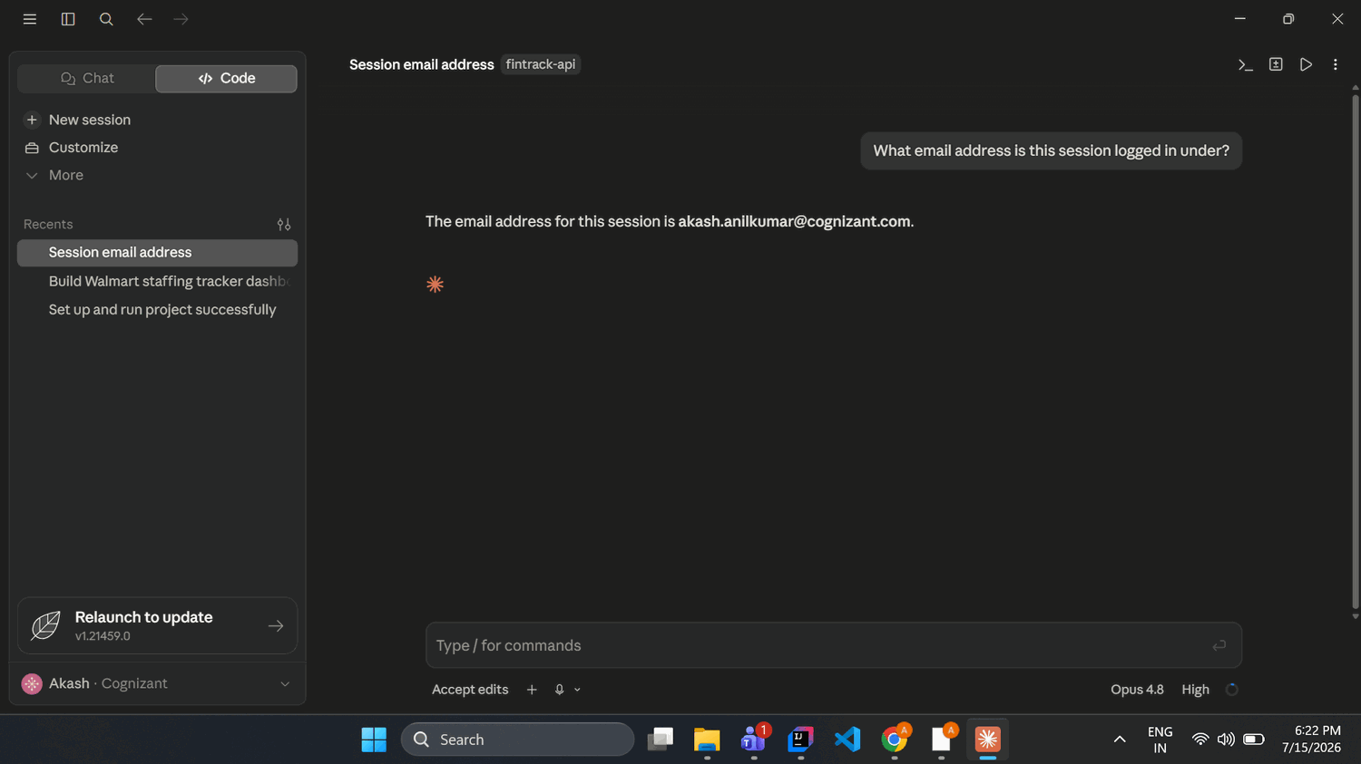
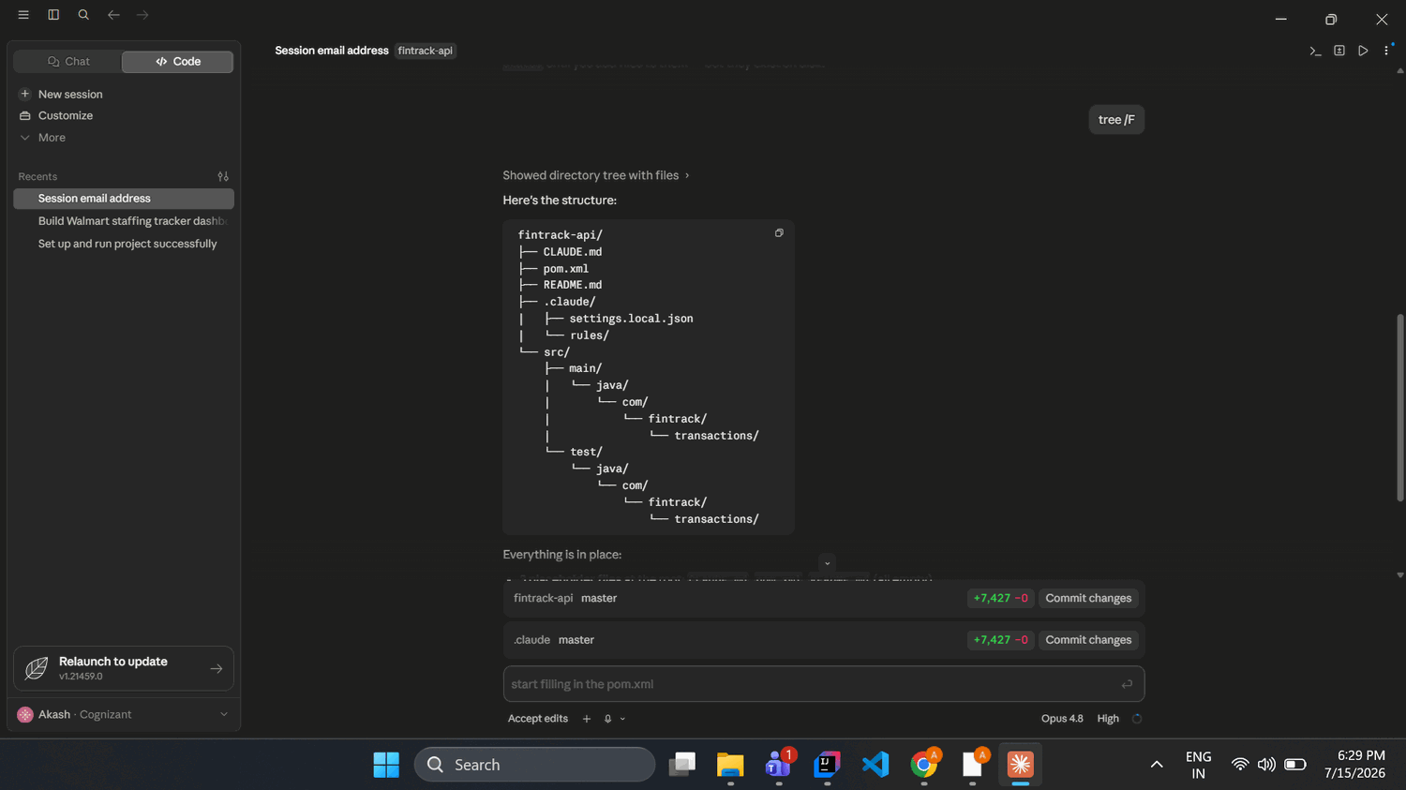
Screenshot 1.2 — CLAUDE.md Content
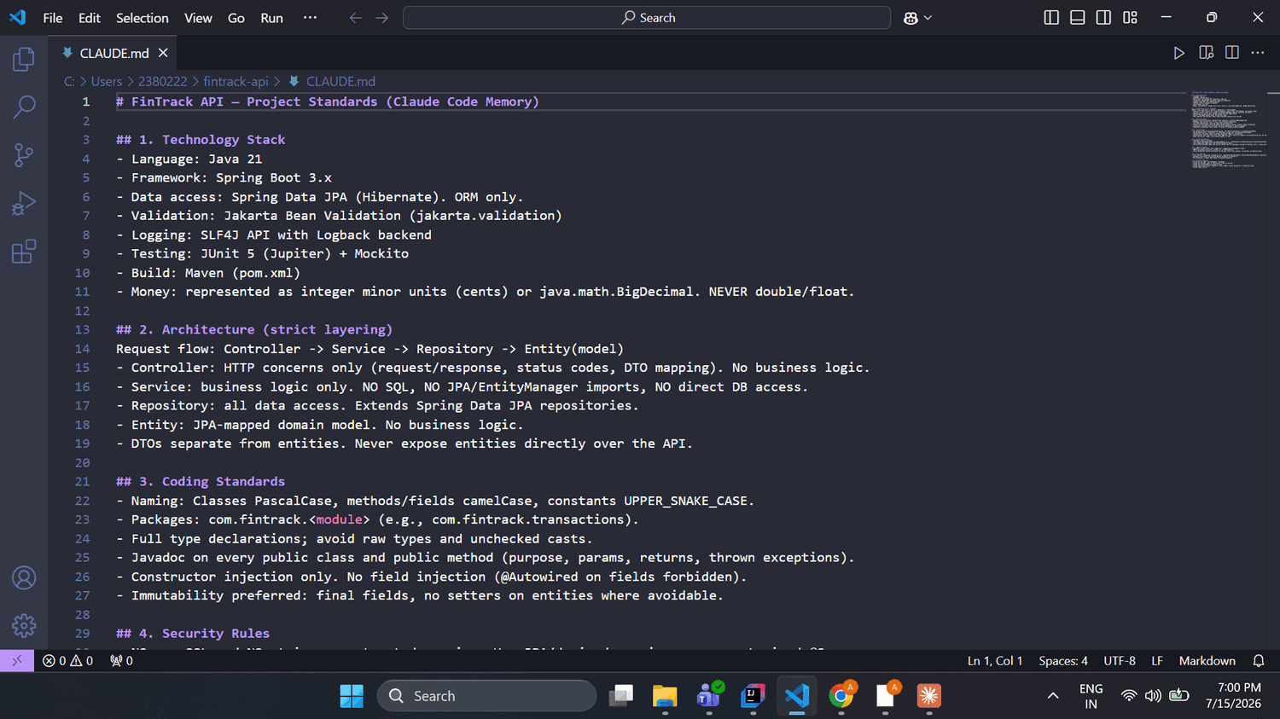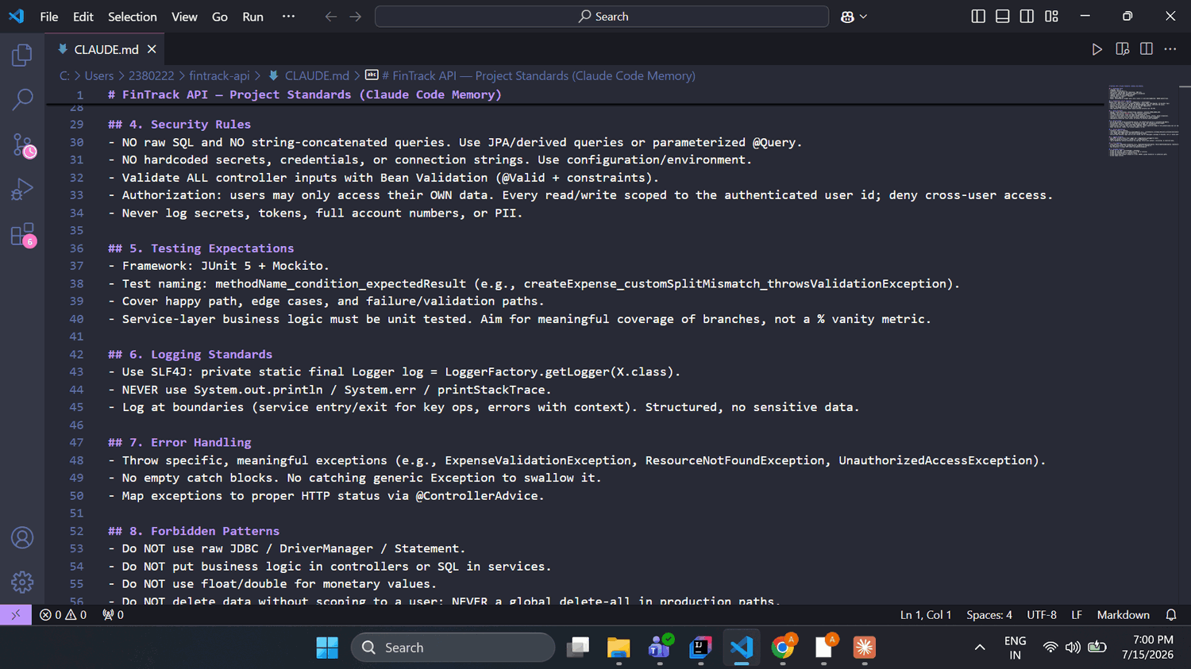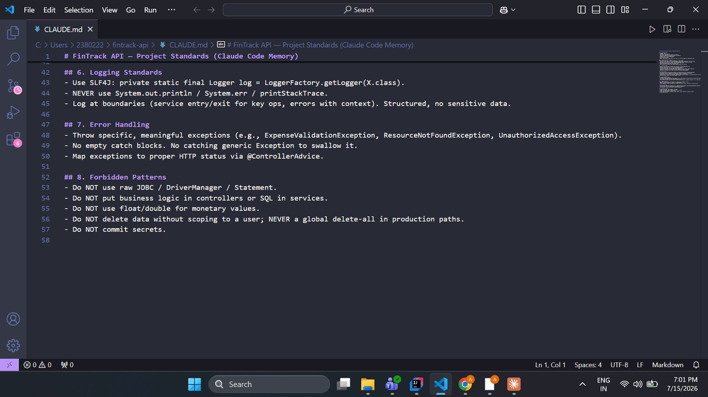
1A — Why CLAUDE.md is structured this way
I structured CLAUDE.md around strict layering and money-safety because in a fintech API the two failure modes that cause the most damage are cross-user data leaks and monetary precision errors. The rules that matter most are ORM-only / no raw SQL and per-user authorization (which close off injection and IDOR), money as BigDecimal never float (which prevents rounding errors in a ledger), and specific exceptions plus structured logging (for traceability and auditability). Because CLAUDE.md is read automatically at the start of every session, these rules shape every developer's generated output without anyone re-typing them, which is how the whole team gets consistent, standards-compliant code.

Section 2 — Transaction Module: AI Generation
The low-effort prompt was run exactly as required, unmodified: “Generate a Transaction model and a Transaction service with create, get-by-user, and delete-all functions. Use a database.” The generated files were saved without modification.
Screenshot 2.1 — The Low-Effort Prompt
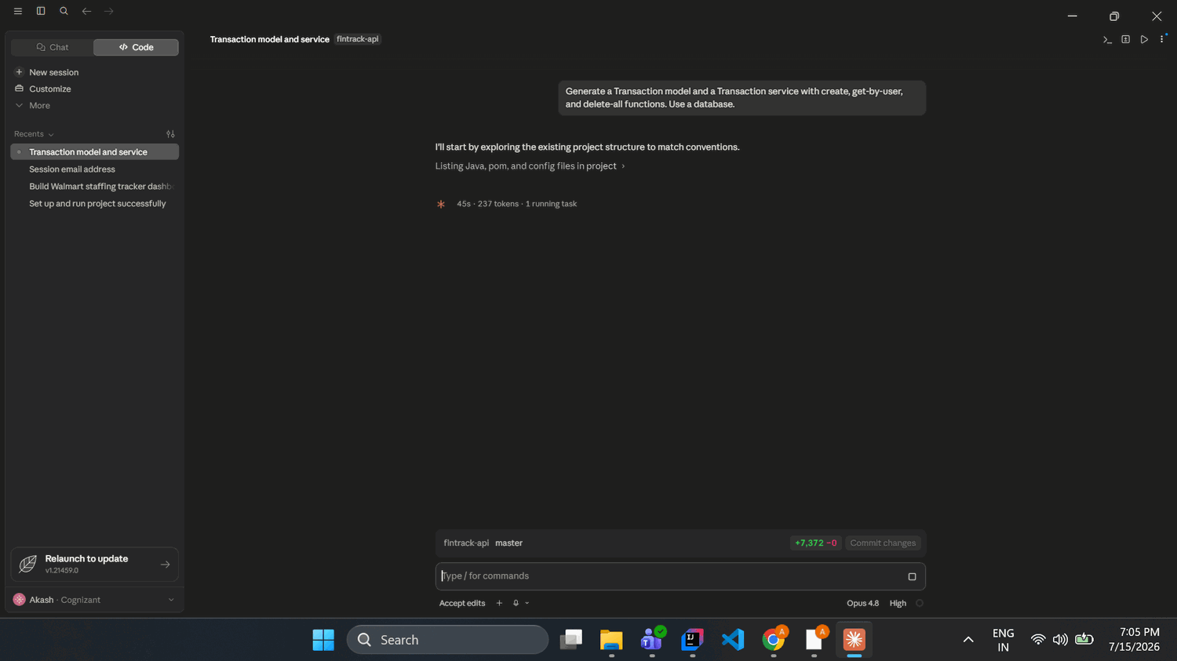
Screenshot 2.2 — Generated Files
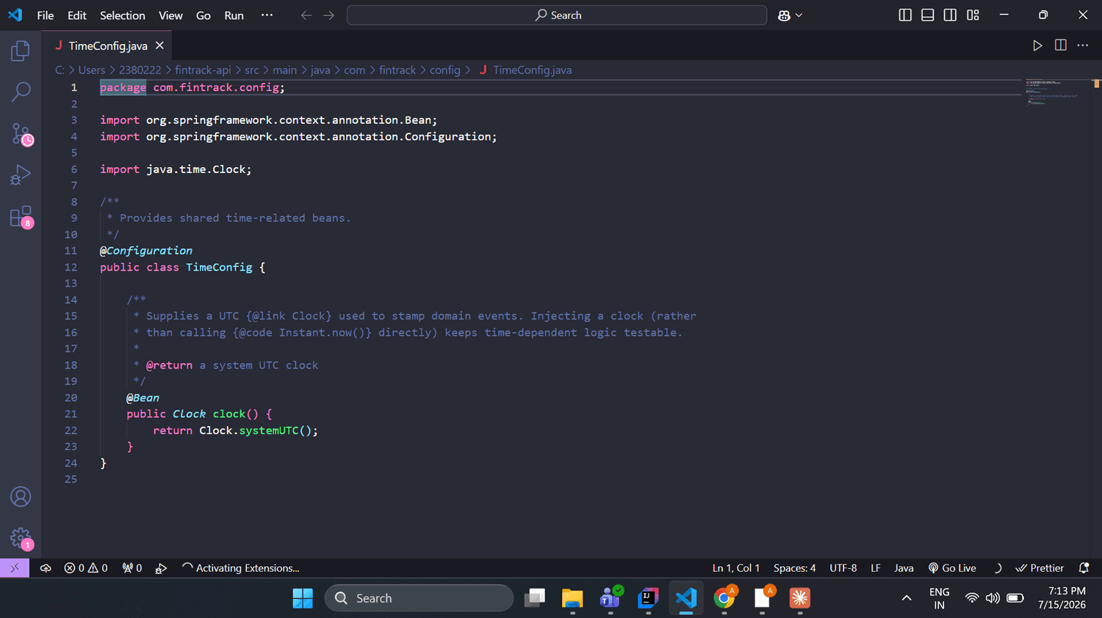
2A — First impressions
My first impression was that the generated code was far cleaner than I expected from such a low-effort, one-line prompt. It already had a proper entity → repository → service split, used BigDecimal for money, constructor injection, SLF4J logging, Javadoc, and validation DTOs. What actually jumped out was why: this quality came from my CLAUDE.md being loaded at session start, not from the prompt — the prompt alone would never have produced this. Even at a glance, the thing that looked potentially problematic was that every service method takes a userId as a plain parameter with nothing binding it to an authenticated user, and create() had no guard against duplicate submissions.

Section 3 — Code Review of AI Output
Screenshot 3.1 — Using Claude Code for Review


Screenshot 3.2 — An Issue Caught by Human Judgment
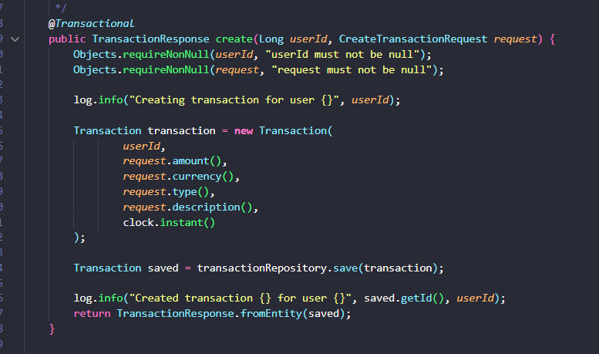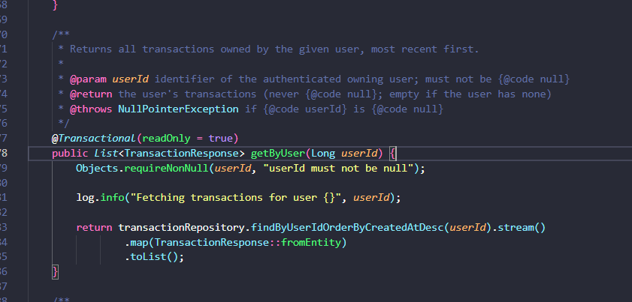
Review Findings Table
# | Location (file + function) | Category | Severity | What's wrong & fintech impact | How detected | Recommended fix
1 | TransactionService (create / getByUser / deleteAllForUser) — userId: Long | Security | Critical | userId is trusted, never bound to the authenticated principal. A controller passing a client-supplied id lets any user read/delete another user's ledger (IDOR/BOLA). | Manual review (the tool's general review wrongly called this safe — see 3A) | Derive user id from the authenticated principal, never client input; add a deny check
2 | TransactionService.create | Bug | High | No idempotency/dedup. A retried or double-tapped request creates a duplicate ledger entry = double-counted money. | Manual review (named it; tool confirmed) | Idempotency-Key header, unique constraint on (user_id, key), return existing on repeat
3 | getByUser → findByUserId… | Performance | High | Loads a user's entire transaction history into memory, no paging — heap exhaustion / DoS at scale. | Claude Code @-reference review | Accept Pageable, return Page<TransactionResponse>
4 | TransactionRepository extends JpaRepository | Security | Medium | Inherits unscoped deleteAll()/deleteAllInBatch() — a global-wipe capability exposed on the bean, one autowire from disaster. | Claude Code verification prompt | Narrow to Repository marker; expose only scoped methods
5 | create vs CreateTransactionRequest | Bug | Medium | Amount rules (positive, ≤4dp) live only in DTO annotations; create re-checks nothing, so a non-web caller can persist a negative/over-scale amount (silent rounding). | Claude Code @ review + CLAUDE.md-compliance prompt | Re-assert invariants in the service; throw a domain exception
6 | Missing controller + @ControllerAdvice | Architecture | Medium | No web layer and no exception→HTTP mapping; violates CLAUDE.md §2/§7. | Manual review | Add controller + @ControllerAdvice
7 | TransactionService — only Objects.requireNonNull | Standards | Medium | Only generic NullPointerException; none of the required domain exceptions exist (§7). | Claude Code CLAUDE.md-compliance prompt | Introduce specific exception types
8 | Transaction / create return | Bug | Medium | Amount isn't canonicalized; create echoes the client's scale (100.5) while reads return scale 4 (100.5000). BigDecimal.equals is scale-sensitive → breaks reconciliation/caching. | Claude Code security-role prompt | setScale(4, RoundingMode.UNNECESSARY) on the way in
9 | repo deleteByUserId (derived) | Performance | Low | Derived deleteBy… does select-then-delete (SELECT + N deletes) instead of a bulk delete. | Claude Code @ review | @Modifying @Query bulk delete
10 | repo ordering | Bug | Low | Orders by createdAt only; equal timestamps → nondeterministic order / unstable pagination. | Claude Code @ review | Add tiebreaker: …OrderByCreatedAtDescIdDesc
3A — Issues that required human judgment
Issue 1 — Authorization (the tool gave a false all-clear). My first, general review from Claude Code explicitly reassured me there was “no IDOR surface — every method is userId-scoped, Good.” That was wrong. “Scoped by a caller-supplied id” is not the same as “authorized” — if a controller wires that id from client input, any user can read or delete another user's transactions. It took a security-specific prompt plus my own knowledge of the BOLA/IDOR threat model to see it. A human must catch this because the tool can state, with confidence, that unsafe code is safe.
Issue 2 — Idempotency on create. Across three separate review passes, Claude Code never raised this until I named it directly. The code reads as correct because it only fails under real-world conditions — a network retry or a double-tap — that the tool doesn't simulate; in a ledger, that means a duplicated, double-counted transaction. Catching it needs production and money-domain reasoning, not just reading the code.
These matter especially with Claude Code because it writes files straight to the filesystem — there is no “are you sure?” step. Plausible, well-formatted, even confidently-reviewed code lands in the repo immediately, so a human review gate isn't optional; it's the only thing standing between generated code and production.

Section 4 — Transaction Module: Remediation
Screenshot 4.1 — Remediation Plan & Approval
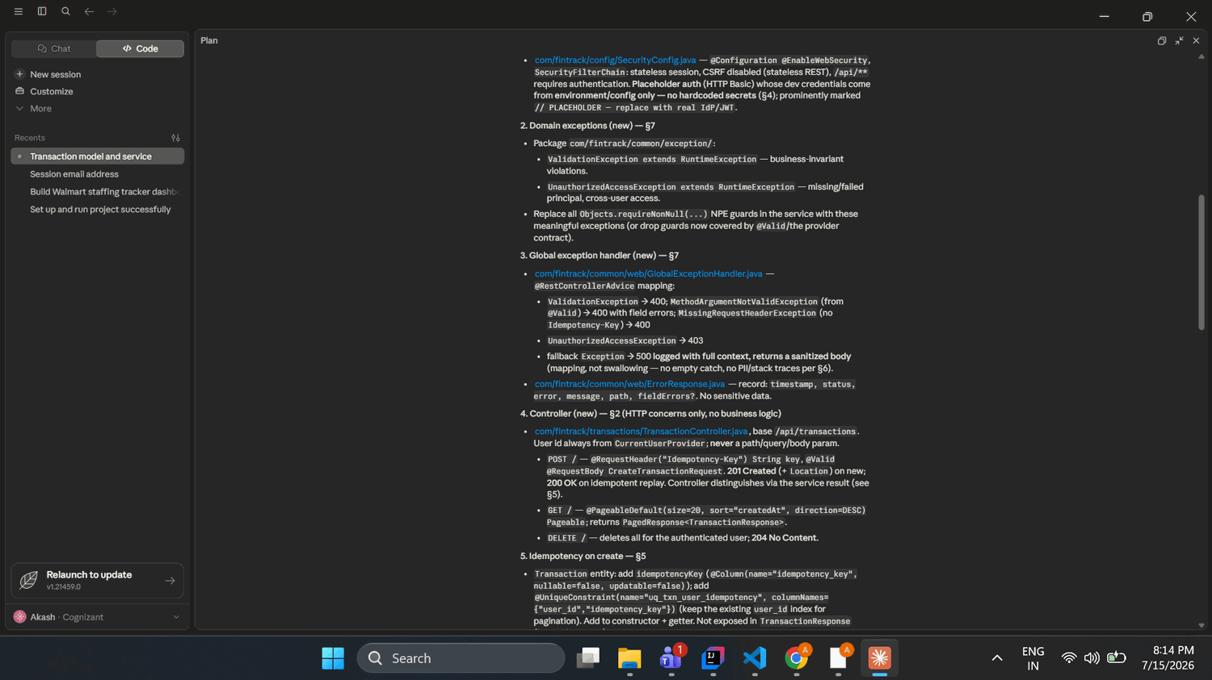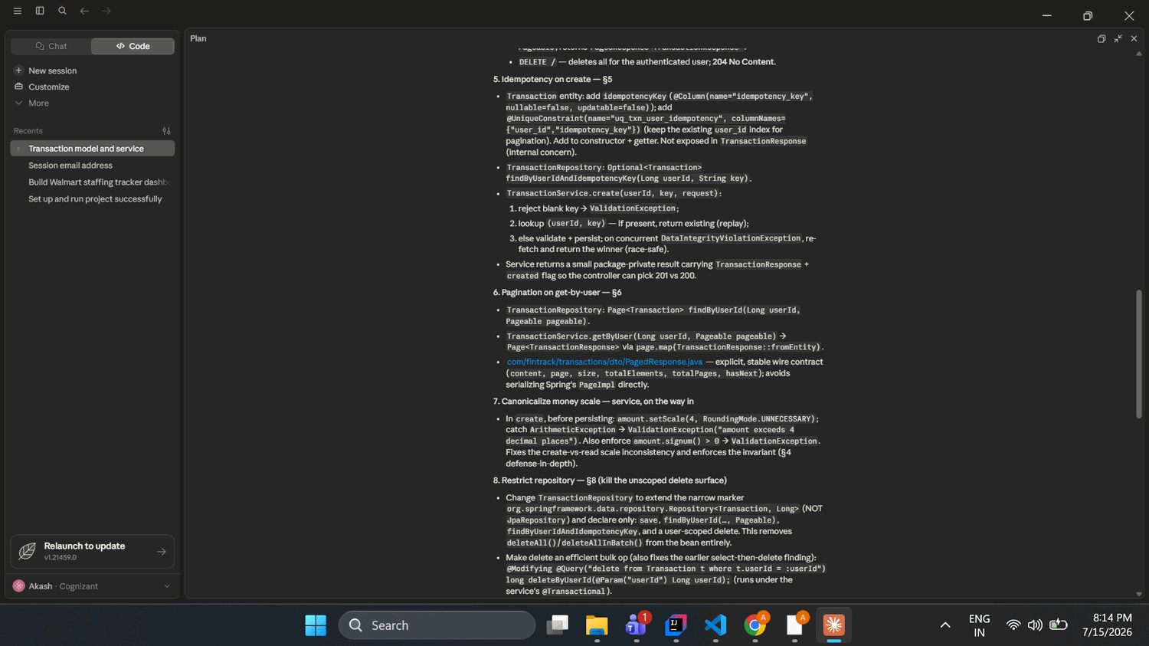
Screenshot 4.2 — Remediated Code (key files)
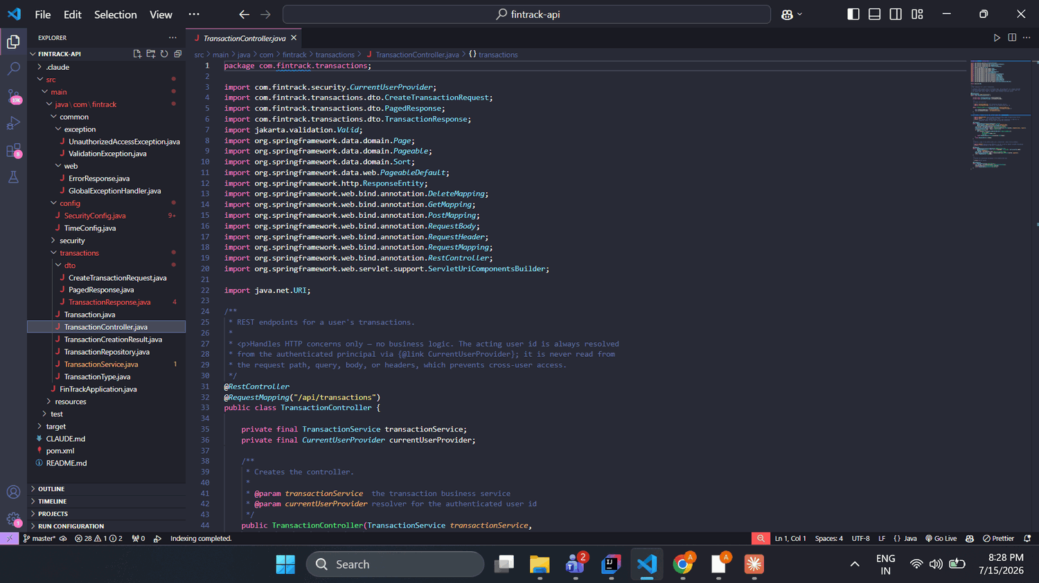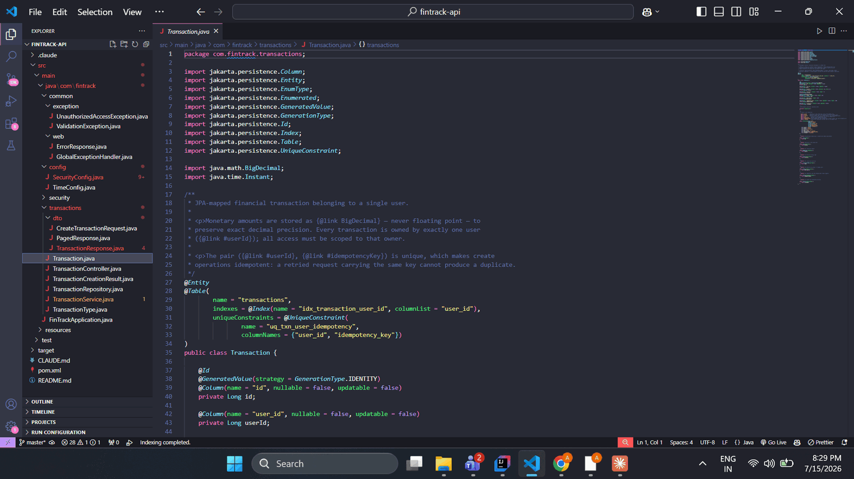
4A — The 3 most important changes
1. Authorization — from a trusted parameter to an authenticated identity. The original code took userId as a plain argument and trusted it, meaning any caller passing another user's id could read or delete that user's transactions (IDOR/BOLA — the top API breach class). The remediation introduces Spring Security and a CurrentUserProvider seam so the controller resolves the user id from the authenticated principal and never from client input. This matters because in a fintech system the authorization boundary is the difference between a scoped ledger and a data breach — and it must be enforced by code, not by a comment.
2. Idempotency on create. The original create unconditionally inserted a row, so a retried or double-submitted request produced a duplicate transaction — a double-counted entry in a financial ledger. The fix accepts a standard Idempotency-Key header, enforces a unique constraint on (user_id, idempotency_key), returns the existing transaction on a replay, and resolves the concurrent-duplicate race via the constraint. This matters because network retries are normal in production, and in money systems a duplicate is real financial error.
3. Money invariants enforced in the domain, with canonical scale. Previously amount rules lived only in the DTO annotations, so any caller bypassing @Valid could persist a negative or over-precise amount that the database would silently round. The service now re-validates every amount (signum() > 0) and canonicalises it with setScale(4, RoundingMode.UNNECESSARY), rejecting excess precision as a ValidationException rather than rounding it away. Silent money mutation is one of the most damaging fintech defects, and validity shouldn't depend on an optional upstream annotation.
Honourable mentions: specific domain exceptions + @ControllerAdvice (§7), narrowing the repository to remove the unscoped delete surface (#8), and pagination on get-by-user.

Section 5 — Expense Splitting Feature: New Build
Screenshot 5.1 — Prompt Chain

Screenshot 5.2 — Context Management
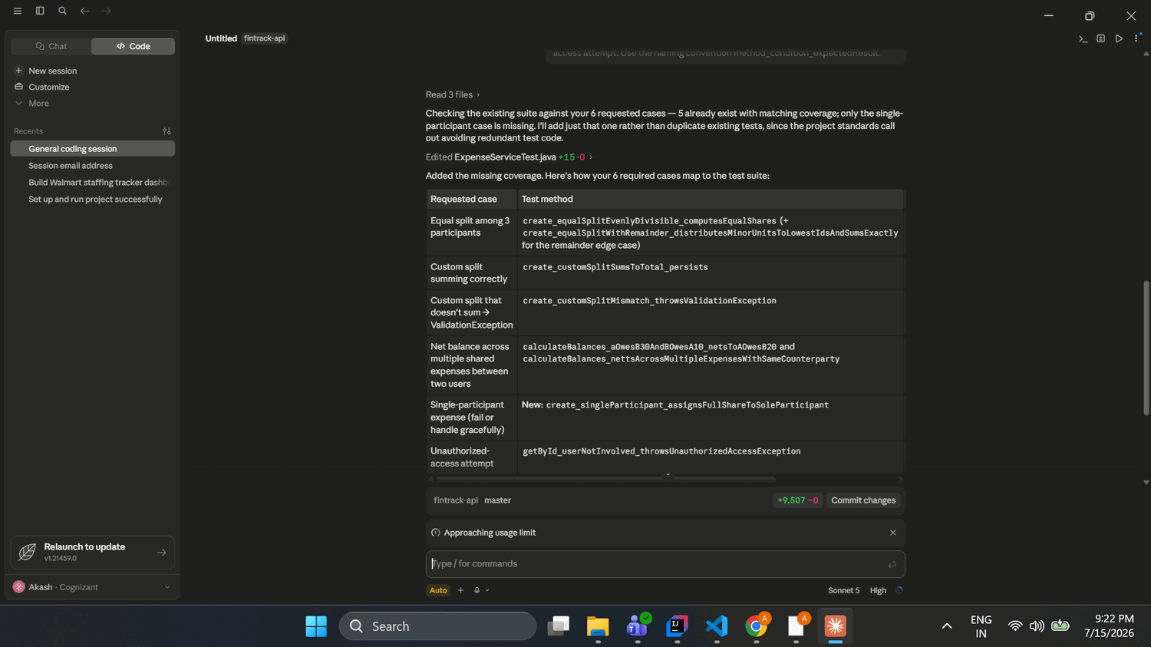
Screenshot 5.3 — Generated Expense Splitting Code
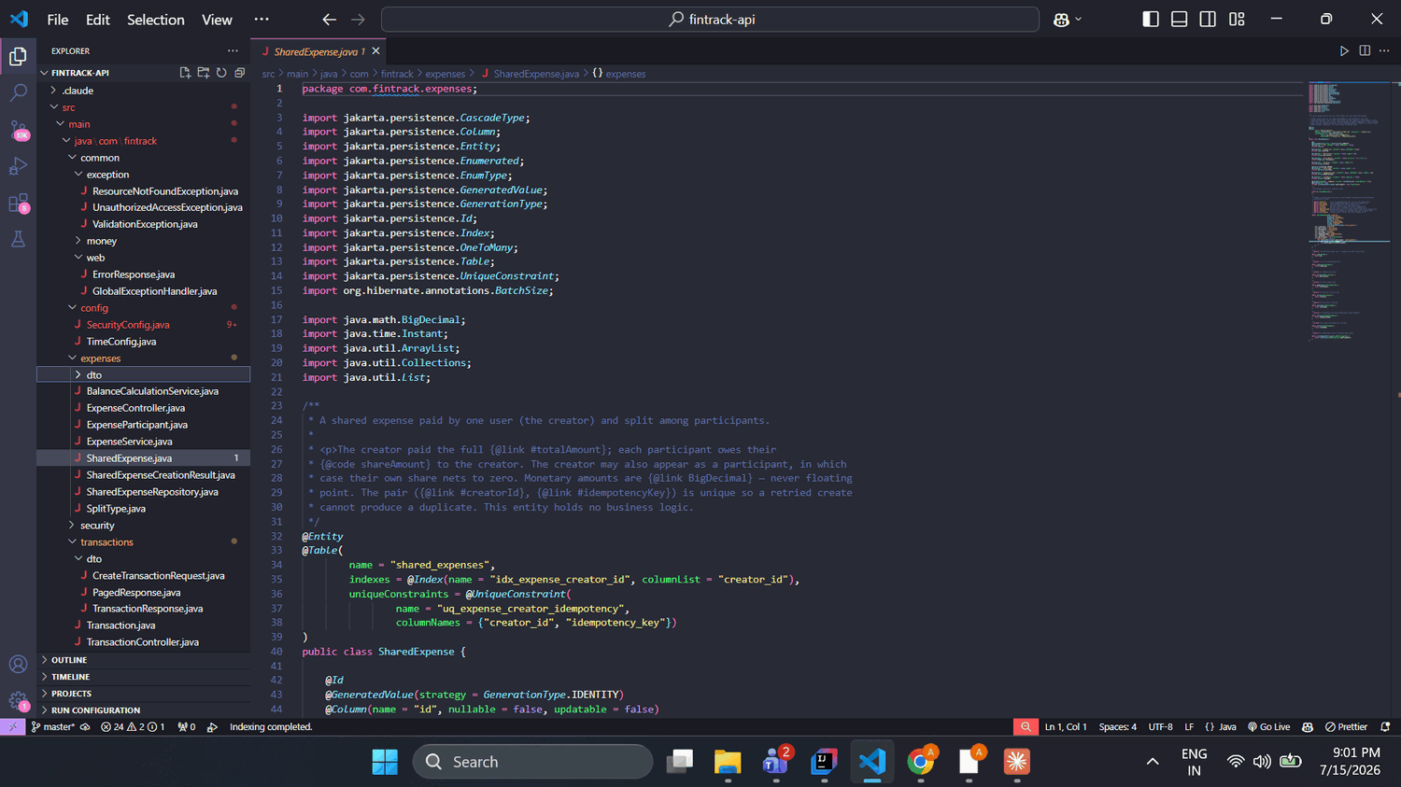
Screenshot 5.4 — Tests
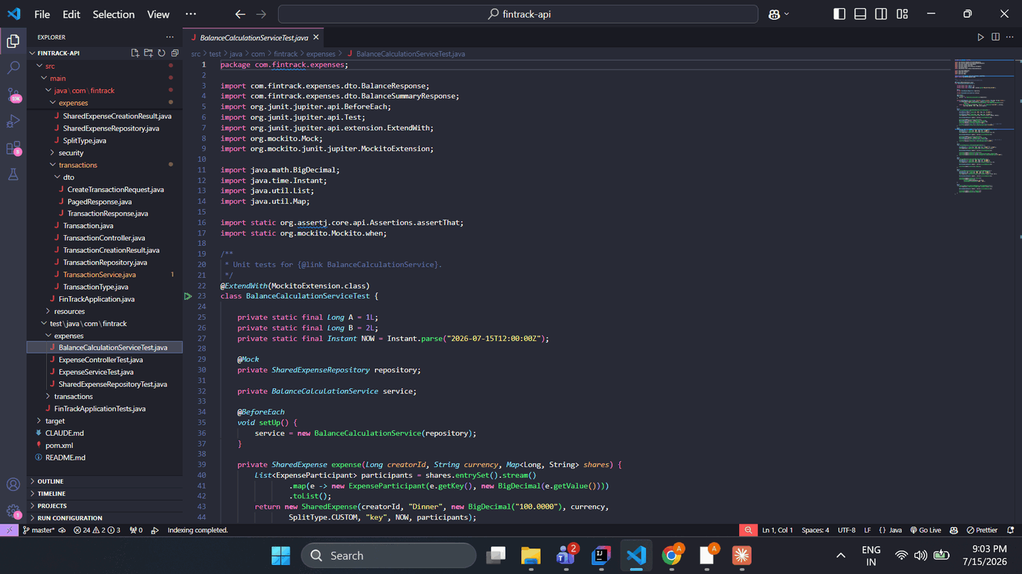
Prompt Engineering Documentation
Prompt # | Prompt text (summarised) | Claude Code feature | Technique | Why this approach
1 | Plan the Expense Splitting feature (SharedExpense model, balance service, endpoints, tests). Plan only — don't write code; ask about design decisions. | Plan Mode (plan pane) | Decomposition | Break a large feature into a reviewed plan before any file is written; surface design forks
2 | Implement SharedExpense model + BalanceCalculationService. Money as BigDecimal; custom shares must sum exactly to total or throw ValidationException; equal split distributes remainder cents deterministically; net balances between users. | Interactive terminal / CLAUDE.md-driven | Constraint | Pin down the money-correctness rules explicitly so the generated logic can't drift
3 | Add REST endpoints following the TransactionController pattern: POST create expense, GET pending balances. User id from CurrentUserProvider, never client input. | @ file reference (pattern reuse) | Specificity | Name the exact pattern to copy so the new controller matches the remediated one
4 | Write JUnit 5 + Mockito tests, ≥6 cases (equal/3, custom OK, custom mismatch → error, net balance across expenses, single participant, unauthorized). Naming method_condition_expectedResult. | Interactive terminal | Few-shot / Iterative refinement | Enumerate the exact cases and naming so coverage is complete and conventional
5 | Review the equal-split logic and confirm remainder cents sum exactly to the total; show me that method. | Iterative refinement | Iterative refinement | Verify the highest-risk money path rather than trusting it
Requirements met: ≥2 Claude Code features (Plan Mode + @ file references, plus interactive terminal and /compact) and ≥3 techniques (decomposition, constraint, specificity, few-shot/iterative refinement).
5A — Post-Generation Corrections
- Design corrections via Plan Mode's questions: steered the feature to existing-user identity (not free-form names), kept expenses decoupled from transactions (no Transaction rows written on expense creation) to avoid double-counting balances, chose “creator pays, may be a participant,” and netted-pairwise balances with no settlement — rejecting the tool's broader options.
- Verified the equal-split remainder handling: the tool implemented exact-sum splitting in integer minor units (MoneyMath), confirmed by the test create_equalSplitWithRemainder_distributesMinorUnitsToLowestIdsAndSumsExactly. No correction needed — checked rather than assumed.
- Balances response shape: the tool asked whether to return a single signed net list or separate owedToMe/iOwe arrays; I kept the signed net list as it already encodes both directions and satisfies the brief.
- Tests could not be executed in the environment (no Maven, JDK 23 vs project's 21); flagged as unrun rather than claimed passing.

Section 6 — Collaboration & PR Readiness
PR Description
Summary: This PR delivers the Expense Splitting feature for the FinTrack API, built on a remediated Transaction module. It first establishes project standards via CLAUDE.md, then hardens the previously unreviewed AI-generated Transaction code (fixing a critical authorization gap, adding idempotency, domain validation, and a proper web layer), and finally adds shared-expense creation with equal/custom splits and a netted pairwise balance calculation. All work follows strict controller → service → repository → entity layering, with BigDecimal money and per-user authorization throughout.
AI Tool Disclosure
- Features used: CLAUDE.md (project memory), Plan Mode (remediation and feature build), the desktop Code tab's plan pane and interactive design questions, @ file references (cross-module consistency), /compact (context management), and /model (Opus for planning, Sonnet for execution).
- Accepted as-is vs overridden: accepted most generated code after review — the entity, repository narrowing, and net-balance logic were correct. Actively steered design via Plan Mode questions (existing-user identity, decoupling expenses from transactions to avoid double-counting, creator-pays-may-participate, netted-pairwise balances). Verified the equal-split remainder rather than trusting it.
- AI vs hand-written estimate: roughly 85–90% AI-generated, 10–15% my direction and corrections — but 100% human-reviewed before inclusion.
- Did CLAUDE.md improve output? Yes, substantially. The initial low-effort prompt still produced layered, BigDecimal, documented code purely because CLAUDE.md was loaded at session start; the same prompt without it would have produced far weaker code.
- Plan Mode for multi-file changes? Yes — both the transaction remediation and the expense feature were planned and approved before any file was written.
- /compact or /clear? Yes — used /compact after the remediation, before building the feature, to free context while keeping the key decisions.
Testing
JUnit 5 + Mockito. Coverage: equal split among 3 participants, valid custom split, invalid custom split (rejected), net balance across multiple expenses, single-participant edge case, and unauthorized access. Known gap: tests could not be executed in the authoring environment (no Maven; JDK 23 vs the project's 21), so they are written but not yet run — they need mvn test on a JDK-21 machine to confirm green.
Risks & Trade-offs
The authentication layer is a runnable placeholder behind a CurrentUserProvider seam, not a real identity provider — the seam is production-correct, but real JWT/OIDC still needs wiring in. Trade-off accepted to keep the PR self-contained and reviewable.
Self-Review Checklist
- ✓ No hardcoded secrets or PII (dev credentials from env only)
- ✓ All inputs validated (Bean Validation + service-layer invariants)
- ✓ Specific exceptions (ValidationException, UnauthorizedAccessException), not generic
- ✓ Code follows CLAUDE.md standards
- ✓ All Claude Code output reviewed before inclusion
- ✓ Tests cover happy path, edge cases, and error scenarios
Peer Review Simulation
# | Code location | What should change | Why (benefit / risk)
1 | SharedExpenseService.createExpense (equal split) | Confirm the remainder cents are distributed in integer minor units so shares sum exactly to the total; keep an explicit assertion that sum(shares) == total as a regression guard. | AI blind spot: splitting $10 three ways must yield 3.34/3.33/3.33, not three rounded shares that lose or add a cent — a ledger cannot silently gain or drop money.
2 | TransactionController.create | Validate the Idempotency-Key header's format/length; an empty or absurdly long key is currently only caught at the database. | Fail fast with a clear 400 instead of a persistence-layer error; better client experience and defence-in-depth.
3 | BalanceCalculationService.calculateBalances | findAllInvolvingUser loads every involved expense into memory to net in-app; flag for a future aggregate query or pagination. | Works now, but won't scale for a heavy user — memory pressure and slow responses.
6A — Why the AI blind spot is missed
Remainder-cent distribution is missed by AI tools because the code looks correct and compiles — dividing a total by a count is the obvious implementation, and the defect only surfaces for specific non-divisible amounts under a “shares must sum to the exact total” business rule the tool wasn't explicitly reasoning about. A human catches it because they know that in a ledger a lost or invented cent is a real reconciliation failure, and they test the awkward case ($10/3) rather than the clean one ($9/3).

Section 7 — Tool Strategy & Reflection
Feature Usage Log
# | Where in the case study | Feature used | Why this feature (not another) | What happened
1 | Project standards | CLAUDE.md | Loads every session automatically, so standards apply without re-prompting | The low-effort prompt still produced layered, BigDecimal, documented code because CLAUDE.md was in place
2 | Initialising the project | /init | Generates a starter CLAUDE.md rather than writing from scratch | It asked how to handle an empty repo; chose a minimal skeleton, then overwrote with full standards
3 | Transaction remediation | Plan Mode (plan pane) | Multi-file, security-sensitive change — needed review before any write | Asked design questions (auth principal, idempotency transport), produced a plan, I approved, then it executed
4 | Reviewing the AI code | @ file references | Point the tool at the exact module instead of it guessing | General review wrongly called authz safe; a security-specific prompt then caught the IDOR gap
5 | Building the feature | Interactive design questions | Surface architecture forks before coding | Steered to existing-user identity + decoupled expenses, avoiding double-counting
6 | Long session, before feature build | /compact | Context was filling after the transaction work; free space while keeping decisions | Compacted history so the feature build kept the key context
7 | Executing the feature | /model (Opus → Sonnet) | Opus was slow for straightforward generation; Sonnet is faster for execution | Switched model to speed up the build after planning on Opus
Scenario Responses
- Understand a complex 500-line function → a sub-agent / Explore agent. It reads and summarises the code in its own context and returns just the explanation, so the main session stays clean and I get a focused walkthrough before touching anything.
- Refactor 10 files to a new logging library safely → Plan Mode. It produces a full cross-file plan I approve before any edit, so I see the whole blast radius and nothing changes until I say go.
- Quickly check a regex's edge cases → a quick interactive prompt (optionally /effort low). It's small and isolated, so a normal-mode one-off is faster than a heavier workflow.
- CI/CD quality checks, no human → headless mode (claude -p “…”). It runs non-interactively in a pipeline and returns output for the build to act on, with no terminal interaction.
- Review a teammate's AI-generated auth module for vulnerabilities → @ file references + a security-focused sub-agent, in Plan Mode so it stays read-only. I point it at the exact files and it audits without modifying anything.
- Consistent conventions across all devs and sessions → CLAUDE.md, committed to the repo. It is read at the start of every session for everyone, so standards apply without each developer re-specifying them.
- 45 minutes in, suggestions getting worse → /compact (or /clear if switching tasks). Context has filled and quality degrades before the hard limit; compacting summarises history and restores accuracy.
- Auto-run the test suite on every file write → hooks (a PostToolUse / file-write hook). It runs deterministically outside the model, triggering the test command automatically whenever Claude Code writes a file.
Limitations Encountered
# | What you prompted | What Claude Code produced | How you detected it | How you fixed it | What you'd prompt differently
1 | “Create 4 git commits…” | git init had run in C:\Users\2380222 (home directory), not fintrack-api — git status showed the entire home folder as untracked | The tool itself flagged the repo root was wrong and refused to commit | Told it to re-init inside fintrack-api; verified the scope | Confirm the working directory (git rev-parse --show-toplevel) before any git operation, and set the project folder as the repo up front
2 | “Review this Transaction module for bugs, security, and architecture problems” (general) | Reassured me there was “no IDOR surface — every method is userId-scoped, Good” | My own knowledge of BOLA/IDOR — a trusted userId parameter is not authorization | Ran a second, security-specific prompt that surfaced the gap; fixed it in remediation | Lead with a threat-model-specific review (“audit for IDOR/BOLA; assume userId is attacker-controlled”) rather than a generic “find issues”
3 | Remediation / feature build (write and verify tests) | Wrote full test suites but could not run them — “no Maven; JDK 23 vs project's 21” | It stated it couldn't execute the build; no green/red result | Noted tests as unrun; they need mvn test on a JDK-21 machine before merge | Ensure a JDK-21 + Maven environment first, or ask it to add a Maven wrapper (mvnw) so the build is self-contained

Section 8 — Architecture Documentation
The FinTrack API is organised into two feature modules — transactions and expenses — that share a common foundation but stay deliberately decoupled. Both follow a strict layered architecture: a Controller handles HTTP concerns only, delegates to a Service that holds all business logic, which delegates persistence to a Repository, which maps to a JPA Entity. Data flows one way — route → service → repository → entity — and never skips a layer; the service contains no SQL or persistence imports, and the controller contains no business logic.
The two modules relate through shared conventions rather than direct coupling. The expense-splitting feature reuses the transaction module's patterns — the same CurrentUserProvider authentication seam, the same BigDecimal money handling, the same domain-exception vocabulary, and the same numeric-userId identity model. Crucially, creating a shared expense does not write transaction rows; balances are derived purely from the expenses themselves. This avoids double-counting and keeps each module independently testable.
This architecture suits a fintech application for three reasons. Security: the user id is always resolved from the authenticated principal, never from client input, so cross-user access (IDOR/BOLA) is prevented by design at the controller boundary. Correctness: money is handled as BigDecimal with canonical scale and exact-sum splitting in integer minor units, so no cent is ever lost or invented. Maintainability and auditability: strict layering isolates each concern, structured logging and specific exceptions make behaviour traceable, and the CurrentUserProvider seam lets a real identity provider (JWT/OIDC) replace the placeholder without touching business logic.
Key design decisions: derive identity from an auth seam rather than trusting parameters; keep expenses decoupled from transactions to avoid double-counting; use a “creator pays, may be a participant” split model with netted pairwise balances; and narrow TransactionRepository to the minimal Repository marker so no unscoped bulk-delete is ever exposed.

